

WHITEPAPER

Invoice finance on the blockchain
By Steve Nico Williams

TABLE OF CONTENTS
ABSTRACT 2
INTRODUCTION 3
EXTENSIBLE BUSINESS REPORTING LANGUAGE ‘XBRL’ 4
USING XBRL IN TARGETED CLIENT ACQUISITION 5
UNDERSTANDING THE ANAYLSIS 8
USING XBRL IN CONJUNCTION WITH BANKRUPTCY CREDIT FORMULAS 8
ALTMAN Z-SCORE FORMULA 9
ACCURACY AND EFFECTIVENESS 9
ORIGINAL Z-SCORE COMPONENT DEFINITIONS VARIABLE DEFINITION 9
Z-SCORE ESTIMATED FOR PRIVATE FIRMS 10
Z-SCORE ESTIMATED FOR NON-MANUFACTURERS & EMERGING MARKETS 10
SMART CONTRACTS 11
HOW OUR SMART CONTRACT WORK WITHIN POPULOUS 11
ACTORS 11
SYSTEM MODULES 12
PLATFORM INTERACTIONS 13
INVOICE AUCTIONS 14
BIDDING ON AUCTIONS 15
WALLET 15
FLOW OF FUNDS 15
DEPOSIT OF FUNDS 16
WITHDRAWAL OF FUNDS 17
CONVERSION OF FUNDS 17
INCENTIVE 18
CONCLUSION 18
REFERENCES 19

ABSTRACT
Applying for a business loan from the bank is not always an ideal solution for small and medium-sized enterprises (SMEs), especially for some businesses that require immediate funding for sudden working capital increases, wages and short-term investments which have not planned for. While large financial institutions and independent invoice finance companies dominate asset-based lending and factoring, Peer-To-Peer (P2P) invoice finance platforms have recently entered the industry. Similar to traditional invoice finance providers, these platforms provide solutions that allow SMEs to get immediate funding on monies owed to them by their customers, rather than waiting for customers to pay invoices within a 45 to 90 day period which usually causes a strain on the cash flow of the SMEs. With the continued rise of P2P lending platforms entering the industry, invoice finance marketplaces are becoming more accessible to businesses globally. The total market size for invoice finance has been growing rapidly and reached over $3 trillion USD worldwide. Not having a deep understanding of credit and underwriting expertise can cause serious financial losses for the P2P platform operators and investors on their platforms. General credit and underwriting experience in this industry are often not enough for building a successful and sustainable invoice factoring operation. What we propose is an invoice factoring platform built using XBRL data to create a new type of credit risk system using credit scoring and bankruptcy formulas such as the Altman Z-Score which can be used to perform an in-depth credit risk analysis on targeted potential borrowers, linked companies, and their customers. While also providing targeted marketing solutions to find borrowers who need invoice finance using methods such as K-means cluster analysis, while also implementing the use of smart contracts on the platform, we can not only prevent duplicate invoice finance fraud but create a cost effective and efficient solution in operating a business with huge global potential.

INTRODUCTION
Keeping a positive cash flow is the most important part for any SME, even more so in an economy which is currently recovering from a recession. After all, having access to the monies owed to an SME allows that SME to create new opportunities, develop existing plans, purchase new equipment, pay salaries and negotiate the best terms with their suppliers. Unfortunately, keeping a regular flow of cash in the business is often easier said than done. Especially if late payments to the SMEs are holding them back. It's currently estimated that late payments are costing UK SMEs as much as £1.9 billion a year. If an SME is selling its products or services to other businesses on credit terms, invoice factoring or invoice discounting also known as invoice finance, could help. It's a form of funding that releases the cash tied up in an SME’s outstanding sales invoices instantly at a cost that both the SME and investor agree on. There are currently over 40,000 businesses across the UK using invoice finance to support them at various stages in their business life cycle. Furthermore, there are businesses across the UK at this moment using this form of finance – particularly at a time when more traditional financial institutions have been turning down funding requests. As of 2016, 50% of SMEs accounted for the UKs total turnover of £3tn and 46% of SMEs experienced some form of cash flow problem and late payment.

EXTENSIBLE BUSINESS REPORTING LANGUAGE ‘XBRL’
XBRL is a global standard for exchanging business information which is freely available. It's also currently used to define and exchange financial information, such as a company’s financial statements. XBRL allows the expression of semantic meaning commonly required in business reporting. Since the announcement in April 2011 that UK companies are required to file their annual accounts and corporation tax returns in this format to the Companies House and HMRC. Some 1.9 million companies are now successfully filing their financial statements in this format each year. The accounts range from complex ones from large organizations to simple reports from small companies. They vary significantly in format and presentation, since they are filed under principle-based accounting standards which do not prescribe the layout of accounts. HMRC uses XBRL data to assess accounts and tax returns, help guide tax risk and policy decisions, judge the consequences of legal challenges and gain a better understanding of the business population. It says that XBRL filing has been extremely successful:

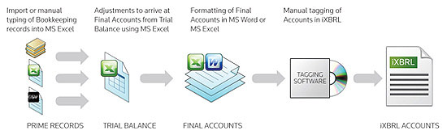

With the UK’s Companies House making 6 years of XBRL data freely available for over 1.9 million UK companies. We have a good starting point to analyzing past financial data and forecast credit risk on companies over various different in industries and sectors. Before this can be attempted we developed a method of extracting the XBRL data from its current document form into our database, this has given us roughly over 2.8 billion points of data yearly which is updated daily as soon as a company files their account to the Companies House for which enables us to perform credit risks analysis.

USING XBRL IN TARGETED CLIENT ACQUISITION
Below we have combined two data sets the first is 2012 charge data, taken from the Companies House and the second is 2012 accounting data extracted from XBRL data, also taken from the Companies House.
Our goal today is to see how XBRL data will prove to be valuable by determining how the selected financial institution's customers are targeted and grouped. The results of this analysis should explain how we intend target clients efficiently and effectively, which ultimately will lead to more SMEs obtaining invoice finance and of course an increase in our revenue model and for investors funding invoice on the platform.

Variables accounted for in this analysis are:
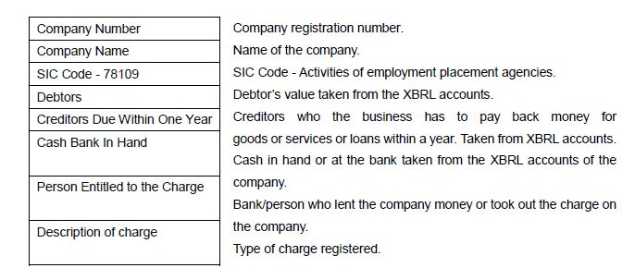

With the combined data set in hand and with a favorable number of observations, we can now take a deeper look into how the data can provide useful insight. Using cluster analysis we are given a number of different approaches towards understanding patterns within any given data set

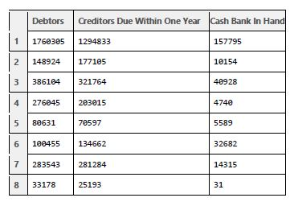
We will focus our analysis on these three variables as our prime concern for each company under the influence of a financial institution. We are using approximately 60 observations. The above record is an example of 8 observations taken from the record. A very reliable way to do this is to group the companies in separate clusters. Each cluster represents the four financial institutions we have used for this analysis.
The financial institutions concerned here are as follows:
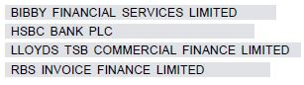
The Clustering algorithm we have used here is called the K-Means Algorithm, which has been statistically implemented on the dataset using the R Programming Language. The objective is to form clusters on the basis of common behavior between the companies in focus from the three variables namely: 1. Debtors, 2. Creditors Due within One Year and 3. Cash Bank in Hand.
The output will produce 4 clusters.
K-means clustering with 4 clusters of sizes 18, 1, 31, 6

Cluster means:

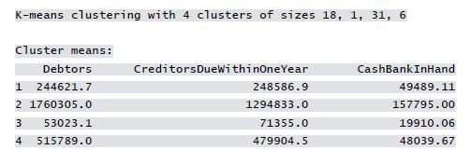

The number of companies in each cluster can be depicted as

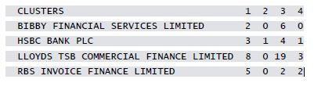

UNDERSTANDING THE ANAYLSIS

After conducting this exercise we can clearly see some interesting and useful insights from the analysis. For example, there is a larger concentration of companies in cluster 3 than in the other cluster. This indicates that most lenders according to the data set would prefer to lend to companies that have variable values similar to the mean variable values found in cluster 3. Also, still looking at cluster 3, we can see from the analysis that Lloyds TSB Commercial Finance had the most customers in that cluster. This type of analysis would be very useful to a competitor who may wish to know why Lloyds are gaining a larger market share and what level of lending they are providing to their customers to acquire such a large customer base.
In cluster 2, we can see that only HSBC targeted the largest company in the analysis. This could be a strategy worth pursuing knowing that no other lender was willing to lend to a company of that scale. To a lender with deep pockets, this could prove to be a perfect strategy if executed correctly in a growing economy. Furthermore, a lender armed with this sort of analysis could easily target those companies which have been more profitable to them in the past and stay ahead of the competition. The lender could also use the information derived to put strategies in place to take business from competitors, or even corner a relatively young but strongly going sector of the asset based lending industry. Using the K-means cluster analysis can form the basis on which a company can be objectively parameterized, as it will also form the groundwork for further analysis, for example, whether the company is borrowing money greater than its peers within the same industry.

USING XBRL IN CONJUNCTION WITH BANKRUPTCY CREDIT FORMULAS

Being able to extract over 1500+ data points per company is a game changer. This gives us a great opportunity to analyse not only the credit risk of a company in question or their trading partners but the industry as a whole. XBRL data is submitted daily by companies to Companies House and updated on our system instantly, creating a real-time insight to how the UK economy is preforming.
By using XBRL data in conjunction with different formulas such as the Altman Z-Score formula has allowed us to some extent to ineffectively create our own in house crediting rating system more advanced than the current industry standard.

ALTMAN Z-SCORE FORMULA

The Z-score formula for predicting bankruptcy was published in 1968 by Edward I. Altman, who was, at the time, an Assistant Professor of Finance at New York University. The formula may be used to predict the probability that a firm will go into bankruptcy within two years. Z-scores are used to predict corporate defaults and an easy-to-calculate control measure for the financial distress status of companies in academic studies. The Z-score uses multiple corporate income and balance sheet values to measure the financial health of a company.

ACCURACY AND EFFECTIVENESS
In its initial test, the Altman Z-Score was found to be 72% accurate in predicting bankruptcy two years before the event, with a Type II error (false negatives) of 6% (Altman, 1968). In a series of subsequent tests covering three periods over the next 31 years (up until 1999), the model was found to be approximately 80%–90% accurate in predicting bankruptcy one year before the event, with a Type II error (classifying the firm as bankrupt when it does not go bankrupt) of approximately 15%–20% (Altman, 2000). From about 1985 onwards, the Z-scores gained wide acceptance by auditors, management accountants, courts, and database systems used for loan evaluation. The formula's approach has been used in a variety of contexts and countries, although it was designed originally for publicly held manufacturing companies with assets of more than $1 million. Later variations by Altman were designed to be applicable to privately held companies (the Altman Z'-Score) and non-manufacturing companies (the Altman Z"-Score). Neither the Altman models nor other balance sheet-based models are recommended for use with financial companies. This is because of the opacity of financial companies' balance sheets and their frequent use of off-balance sheet items.

ORIGINAL Z-SCORE COMPONENT DEFINITIONS VARIABLE DEFINITION

NOTE: The use of " / " is a stand-in for division (÷)

X1 = Working Capital / Total Assets
X2 = Retained Earnings / Total Assets
X3 = Earnings Before Interest and Taxes / Total Assets
X4 = Market Value of Equity / Total Liabilities
X5 = Sales / Total Assets
Z score bankruptcy model:
Z = 1.2X1 + 1.4X2 + 3.3X3 + 0.6X4 + .999X5

Zones of Discrimination:
Z > 2.99 -“Safe” Zone
1.81 < Z < 2.99 -“Gray” Zone
Z < 1.81 -“Distress” Zone

Z-SCORE ESTIMATED FOR PRIVATE FIRMS
NOTE: The use of " / " is a stand-in for division (÷)
X1 = (Current Assets − Current Liabilities) / Total Assets
X2 = Retained Earnings / Total Assets
X3 = Earnings Before Interest and Taxes / Total Assets
X4 = Book Value of Equity / Total Liabilities
X5 = Sales / Total Assets
Z' Score bankruptcy Model:
Z' = 0.717X1 + 0.847X2 + 3.107X3 + 0.420X4 + 0.998X5

Zones of Discrimination:
Z' > 2.9 -“Safe” Zone
1.23 < Z' < 2.9 -“Grey” Zone
Z' < 1.23 -“Distress” Zone

Z-SCORE ESTIMATED FOR NON-MANUFACTURERS & EMERGING MARKETS

NOTE: The use of " / " is a stand-in for division (÷)
X1 = (Current Assets − Current Liabilities) / Total Assets
X2 = Retained Earnings / Total Assets
X3 = Earnings Before Interest and Taxes / Total Assets
X4 = Book Value of Equity / Total Liabilities
Z-Score bankruptcy model: Z = 6.56X1 + 3.26X2 + 6.72X3 + 1.05X4[4]
Z-Score bankruptcy model (Emerging Markets): Z = 3.25 + 6.56X1 + 3.26X2 + 6.72X3 + 1.05X4

Zones of discriminations:
Z > 2.6 -“Safe” Zone
1.1 < Z < 2.6 -“Grey” Zone
Z < 1.1 -“Distress” Zone

SMART CONTRACTS

The transparency of events along the supply chain via the blockchain is itself a major enabler of faster payments and improved financing, increased efficiency, reduced risk of fraud, and lower costs. Exchanging information related to these events in a distributed ledger facilitates trigger events that need to take place for goods to arrive at their final destination and for suppliers to receive payment. But the capability of the blockchain to facilitate these trigger events does not end with the mere exchange of information along a supply chain. The use of smart contracts to not only trigger events but actually carry them out automatically represents a bold evolution that is being actively explored by a few today. Smart contracts are self-executing computer codes that automatically carry out functions once a triggering event has taken place. It is a linear contract that can include multiple parties (investors, borrowers, buyers, sellers etc.) and that cannot be altered. For example, if a smart contract is written between an investor and a borrower to say that once the investor is victorious in a crowd funding process, 80% of the funds will be released to the invoice seller, a smart contract would automatically disburse payment once confirmation is entered into a distributed ledger that the crowd-funding process as closed. The confirmation of approval by the crowd-funding process is not a triggering event requiring action by a bank; the payment is automatically made once confirmation has been entered into the system. With a smart contract, legal stipulations are embedded in the computer code, which enables the automatic execution of functions defined by a legal contract. It also provides protection against duplicate invoice financing, as the contract will not allow for an invoice that has already been financed to receive additional financing. A smart contract, therefore, acts as an application layer that is built on the blockchain. The development of the blockchain that supports the smart contracts we are developing is already built and readily available and globally known as Ethereum Virtual Machine ‘EVM’ in a number of countries. Some see smart contracts as the future of the blockchain, as they enable more efficiencies in legal contracts through a decrease in manual processing and initiation of contract terms, risk reduction through the elimination of manual errors and duplicate invoice financing, which could make value propositions such as micropayments more feasible.

HOW OUR SMART CONTRACT WORK WITHIN POPULOUS

ACTORS
  - Administrator
The platform administrator approves and manages clients’ accounts and actions.
  - Borrower
Clients can register as borrowers to sell invoices on the platform. The borrower must be reviewed, before he can sell invoices on the platform.
  - Investor
Clients can register as investors on the platform to bid on auctioned invoices. The investor must be reviewed before he can use the platform.

SYSTEM MODULES

The full Populous smart contracts system specification is beyond the scope of the current document and we will review only some of the main modules of the system – bank module, auction module and external tokens module (implements the Ethereum ERC 20 token standard) – which provide the programming interface for interaction with the system. Access to the bank and auction modules’ functionality is restricted to ensure the business operations will be performed only inside the platform. Parts of the external tokens module’s functionality are restricted as well (minting and destruction of tokens), while the functionality described in the ERC 20 specification is publicly accessible to every Ethereum address, which has tokens.
  - Bank
The module manages the internal ledger for all platform accounts and the connection between the internal ledger and the external tokens.
  - Auction
The module manages auction operations. The administrator creates auctions based on the data provided by the borrowers. Investors can use the platform to create investor groups for invoice auctions and make bids on them. The auction module is logically connected to the IPFS distributed web – every invoice auction has hash references to related documents uploaded on the IPFS web.
  - External tokens
Every worldwide government currency, which is supported by the platform, has a corresponding smart contract, which implements the Ethereum ERC 20 token standard. Clients can withdrawal their funds outside the platform into these smart contracts, to gain sovereign access to their tokens.

PLATFORM INTERACTIONS
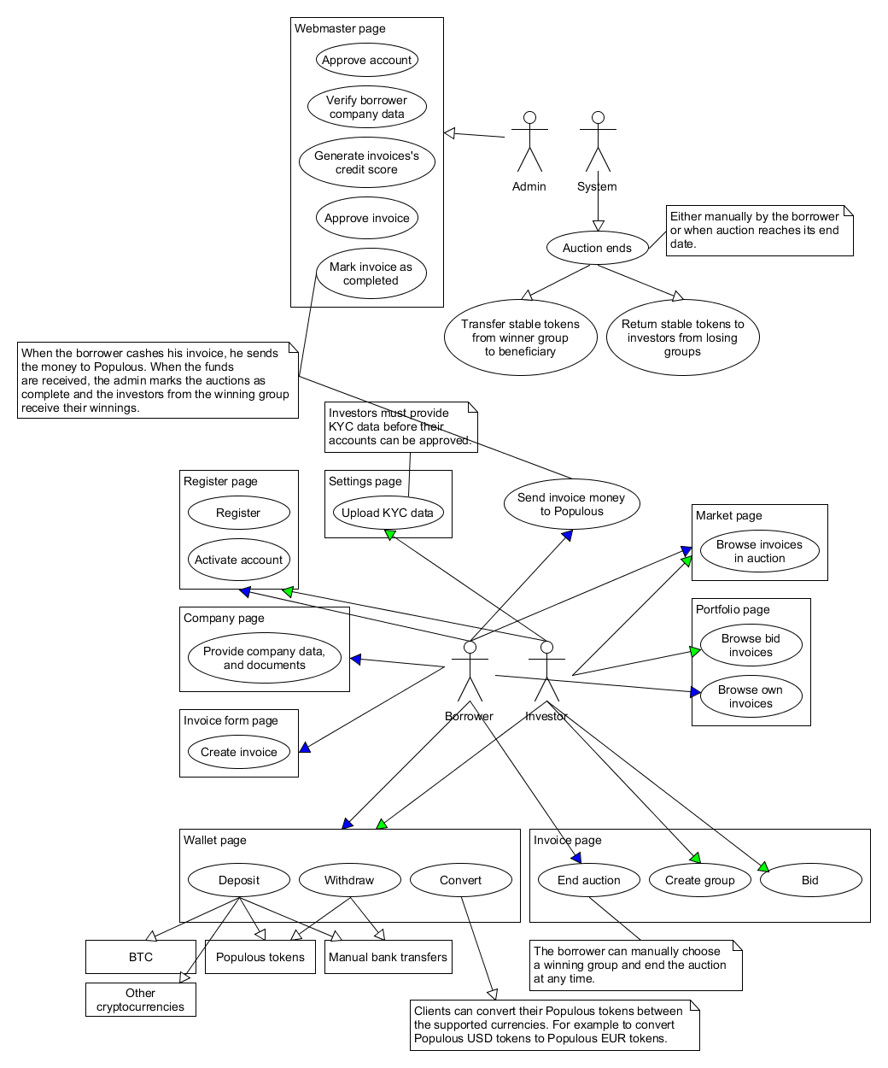

INVOICE AUCTIONS

    - When the borrower registers, he must provide information and documents about his company.
    - The administrator approves or blocks his account based on the provided information.
In the case of approval, the borrower is allowed to sell invoices - he provides data for the invoice and the administrator creates an invoice auction or rejects the invoice:
    - The borrower provides information and documents for the invoice and the auction. Minimal sell value and beneficiary for the auction are defined.
    - The administrator generates a credit score for the borrower’s invoice as described in whitepaper.
    - Based on the credit score the administrator approves or rejects the auction of the invoice and defines service fees.
In the case of approval, the auction of the invoice starts. All auctions are for the duration of 1 day. Investors can create investor groups to bid on the auction as described in 3.2. The auction can end in three ways:
    - There is an investor group, which has reached its goal.
    - The borrower has decided to end the auction before its duration has ended.
      - He can accept the funds from an investors group of his choosing, even if the group hasn’t reached its goal.
      - He can cancel the auction.
    - The auction duration has ended.
      - The borrower has the option to accept the funds from an investors group of his choosing, even if the group hasn’t reached its goal.
If the auction is successful:
    - The beneficiary of the auction receives the funds from the investor group, which has won the auction.
    - The investors from the other investor groups are refunded their bids.
    - When the borrower cashes the invoice, which he has auctioned, he sends the money to the platform.
    - When the funds are received, the investors from the investor group, which has won the auction, receive their winnings. Each investor receives dividends proportional to his bidding contributions.
If the auction is unsuccessful:
    - The borrower has to option to either restart the auction or cancel it.
If the auction is cancelled:
    - The investors from all investor groups are refunded their bids.

BIDDING ON AUCTIONS

    - When the investor registers, he must provide personal information and documents (KYC data).
    - The administrator approves or blocks his account based on the provided information.
In the case of approval, the investor can use the platform to:
    - Deposit funds.
    - Browser active auctions and investor groups in them.
    - Create investor groups for active auctions. Every investor group has a goal. The amount of the goal must be greater than the minimal sell value of the auction and must be less than the invoice amount.
    - Bid on auctions in investor group(s).

WALLET
The usage of the platform wallet is described in 4.2., 4.3., 4.4.

FLOW OF FUNDS

  - Stable currency tokens
The flow of funds within the platform is realized by the usage of custom stable Populous tokens (tokens) pegged 1 to 1 with worldwide government’s currencies. For example, inside the platform, 8 GBP will be represented by 8 Populous GBP token. All operations inside the platform are done with tokens. No operations inside the platform use or rely on Ether. This abstraction allows us to operate on the Ethereum platform and take advantage of its smart contracts, while avoiding direct usage of cryptocurrencies and their volatility. The base currency and stable token for the platform is GBP. The life of the tokens is split into two parts:
    - Stable Populous tokens inside the platform
The platform manages an internal ledger with the balances of each borrower’s and investor’s (actor’s) accounts for each currency. Only the platform has access to this internal ledger. The platform makes internal transactions between the accounts on the behalf of actors based on their actions in the platform.
    - Stable Populous tokens outside the platform
Outside the platform we provide a publicly accessible smart contract for each token, implementing the Ethereum ERC 20 token standard (external token contract). The actors can withdraw their tokens from the platform into the corresponding external token contract depending on the currency of the token. For example, an actor can withdraw his Populous USD tokens into the Populous USD external token contract. The actor provides an Ethereum address to which the tokens are transferred. Upon withdrawal, the tokens are destroyed from the platform’s internal ledger and minted into the corresponding external token contract (the opposite is done, if the tokens are deposited back into the platform). This option gives possibility to the actor to have access to his tokens independently of the platform.

DEPOSIT OF FUNDS

When the actor deposits funds into the platform, an equivalent amount of tokens is minted and deposited into his account. A different token is used depending on the currency of the deposited funds:
    - Deposit worldwide government’s currency
The actor receives the same amount of the corresponding tokens. For example, if the actor deposits 8 USD, he will receive 8 Populous USD tokens.
    - Deposit stable Populous tokens
If the actor has access to tokens in one of the external token contracts, he can deposit them into the platform. Upon deposit, the tokens are destroyed from the external token contract and minted in the platform’s internal ledger.
    - Deposit BTC
The deposited BTC are converted to GBP, based on the current exchange rate and the actor receives Populous GBP tokens equivalent to the GBP amount. The conversion is done manually, by the platform admin, with partner brokers.
    - Deposit other cryptocurrencies
The deposited cryptocurrency is converted to BTC and follows the same procedure described in 3.2.3. The conversion to BTC is done automatically with the help of a third party exchange services.

WITHDRAWAL OF FUNDS

The platform offers two ways for the actors to withdraw funds:
    - Withdraw worldwide government’s currency
The actor can withdraw his tokens for the equivalent of the corresponding worldwide government currency. Platform fees apply upon withdrawal.
    - Withdraw stable Populous tokens
The actor can withdraw his tokens out of the platform into an external token contract as described in 3.1.2. Upon withdrawal, the tokens are destroyed from the platform’s internal ledger and minted in the external token contract.

CONVERSION OF FUNDS

Actors can convert their tokens for other tokens inside the platform. For example, the actor can convert his Populous GBP tokens for Populous USD tokens. The conversions are done with the pair conversion rate for the day for the corresponding worldwide government currencies.

INCENTIVE
The cost of credit insurance can sometimes rise up to 3% for an invoice seller with an invoice value of £100,000. With the implementation of our XBRL system, we see a reduction in this cost for an invoice seller, whose invoice is valued at £100,000. Our approach to credit risk analysis will lead to better understanding of the industry as a whole when making crucial credit decision as well as finding investment opportunities for our investors and funding for our invoice sellers. The use of credit reference agencies and third party data providers will be minimal as we are currently aware that major data providers such as Dun & Bradstreet, Experian etc. are yet to implemented XBRL and still rely on predated methods of compiling their data, which would bear a huge burden on an invoice factoring platform budget should they wish to perform analysis at will which is demonstrated earlier on in this whitepaper. With an overall reduction in the cost subscription to third party services and the reliance on third party data, our resources can be put to greater use in bringing potential customers to the platform and creating value for investor on the platform.

CONCLUSION

Lately, it has become a common perception to a small few that the blockchain and XBRL data integration will play an important role in lending operations, regardless of whether the customer is an established enterprise, or SME with limited or no transaction history. Traditional Invoice finance providers will soon follow suit and try to utilize XBRL data for making credit decisions. We have proposed building a Peer 2 peer lending platform that leverages XBRL data, smart contracts and the blockchain as a solution to help automate whole processes within our invoice finance platform. However, despite the availability of sophisticated algorithms that aid credit decision-making for current invoice finance providers, reliance on "XBRL data" as an effective tool to assess credit risk is not fully there yet, but this is what we hope to change. Financial data is rarely available in the format needed to develop and perform in-depth credit risk and industry analysis.
Other sources of financial data providers such as Experian, Fame and Dun & Bradstreet do provide financial data but at a cost and anyone business considering carrying out analysis on the scale we propose using data hosted by such data providers, will find costs running into the hundreds of thousands of pounds. Thus while we are yet to see the emergence of such a platform as our own. It is still important to remember too that there is no real substitute for a stringent underwriting process, including importantly on-site due diligence of clients (e.g. verifying the physical existence of the business, meeting in person with the owner, and assessing the local business environment).
.

REFERENCES

- https://en.wikipedia.org/wiki/Altman_Z-score
- https://home.deib.polimi.it/matteucc/Clustering/tutorial_html/kmeans.html
- https://www.ethereum.org/token
- http://www.abfa.org.uk/
- https://www.gov.uk/government/publications/xbrl-tagging-requirement-filing-company-tax-returns-online
- https://en.wikipedia.org/wiki/Smart_contract
- https://www.gov.uk/business-finance-explained/invoice-financing
- https://www.cfainstitute.org/Survey/survey_extensible_business_reporting_language_xbrl.pdf
- http://www.dnb.com/content/dam/english/economic-and-industry-insight/payment-study-2016-international.pdf
- http://www.telegraph.co.uk/sponsored/business/business-growth/12011545/sme-late-payment-issues.html
- https://github.com/ethereum/EIPs/issues/20

